School of Design and Informatics  
Abertay University

|  |  |
| --- | --- |
| HOnours Project  CGAD 2023 | Abstract  Exploring the potential of Generative-AI for animations, this project implements the PFNN (Phase-Functioned Neural Network) for character control in Unreal Engine 5.0.  UTKARSH YADAV  1905406 |

Contents

2 ACKNOWLEDGEMENTS 4

3 ABSTRACT 4

4 INTRODUCTION 5

4.1 Research Question 5

4.2 Aim 5

4.3 Background 5

4.3.1 History 5

4.3.2 Deep Learning 6

4.3.3 Generative-AI for 3D Animations 6

4.4 Objectives 7

4.5 Keywords 8

5 Literature Review 9

5.1 PHASE-FUNCTIONED NEURAL NETWORKS FOR CHARACTER CONTROL (Holden, et al., 2017) 9

5.1.1 Introduction 9

5.1.2 Methodology 10

5.1.3 Critical Analysis 11

5.1.4 Conclusion 12

5.2 An improved calculation system for phase-functioned neural network and implementation in Unreal Engine (Kuang, et al., 2018) 13

5.2.1 Introduction 13

5.2.2 Methodology 13

5.2.3 Critical Analysis 14

5.2.4 Conclusion 14

5.3 Neural State Machine for Character-Scene Interactions (Starke, et al., 2019) 15

5.3.1 Introduction 15

5.3.2 Methodology 15

5.3.3 Critical Analysis 17

5.3.4 Conclusion 17

5.4 Local Motion Phases for learning Multi-Contact Character Movements (Starke, et al., 2020) 18

5.4.1 Introduction 18

5.4.2 Methodology 18

5.4.3 Critical Analysis 20

5.4.4 Conclusion 20

5.5 Deep Phase: Periodic Autoencoder for Learning motion Phase Manifolds (Starke, et al., 2022) 21

5.5.1 Introduction 21

5.5.2 Methodology 21

5.5.3 Critical Analysis 22

5.5.4 Conclusion 23

6 Methodology 24

6.1 September 24

6.2 October 24

6.3 November 24

6.4 December 24

6.5 January 25

6.5.1 Procedural Animation System 25

6.6 February-May (PFNN Implementation) 27

6.6.1 External Libraries 27

6.6.2 PFNN Plugin UML Diagram 0

6.6.3 Class Structure 0

7 Results 4

7.1 PFNN Results 4

7.2 Performance 5

8 Discussion 5

8.1 CHALLENGES FACED 5

8.2 Critical Evaluation 11

9 Conclusion 12

10 References 13

11 Appendices. 16

11.1 Appendix 1 16

11.2 Appendix 2 17

11.3 Appendix 3 18

11.4 Appendix 4 19

11.5 Appendix 5 19

Figure 1 Figure 1 The ENIAC released in 1946 5

Figure 2 IBM704 Computer 6

Figure 3 Frank Rosenblatt with The Perceptron 6

Figure 4 State Machine Spaghetti 7

Figure 5 PFNN Visual Diagram 9

Figure 6 PFNN setup in Unreal Engine 13

Figure 7 Neural State Machine 15

Figure 8 Local Motion Phase Visuals 18

Figure 9 Periodic Autoencoder Visual 21

Figure 10 Float Curve 25

Figure 11 Full Body IK node 25

Figure 12 Full Body IK Control Rig 26

Figure 13 Post Process Animation Blueprint 26

Figure 14 Procedural Animation in Unreal Engine 27

Figure 15 PFNN node in the AnimGraph 3

Figure 16 Test Mesh with 31-Joints 5

Figure 17 Physics Asset PFNN 6

Figure 18 Weight Painting 7

Figure 19 UE5 Manny Rigged with 31-Joint hierarchy. 8

Figure 20 PFNN Control Rig 8

Figure 21 PFNN Post Animation Blueprint 9

Figure 22 Trajectory Issue 9

# ACKNOWLEDGEMENTS

I would like to thank my supervisor, Kean Lee Kang for the guidance and feedback provided throughout the duration of my honours project. His mentorship was invaluable. Additionally, I would like to extend my heartfelt thanks to Martin Lynagh, my supervisor from last year's DES310 project. His constructive criticism on my contribution significantly motivated me to refine the animation system for the gecko.

A special note of thanks is due to Jason Beggs (Beggs, n.d.), the animator from the DES310 project. His assistance in the rigging and weight painting process was instrumental and I am deeply appreciative of his contributions.

My roommates and dear friends, Alessandro Bason, David Sutherland, and Saul Bandera Brotheridge, have been pillars of support. Their assistance with my dissertation writing has been monumental, and I cannot express enough gratitude for their unwavering encouragement. I also wish to acknowledge all the staff at Abertay University. Their dedication to the CGAD coursework and the overall educational experience has been indispensable to my growth and success. Their contribution has truly enhanced my university experience.

Furthermore, my project and dissertation have greatly benefited from the support of ChatGPT and other emerging AI technologies. These tools did more than just assist me; they kept me motivated by constantly showcasing the potential of what AI could achieve. I am deeply thankful for the help they have provided and look forward to exploring more of what AI can offer in the future.

# ABSTRACT

This dissertation investigates the application of deep learning models for real-time character animation in industry-standard game engines, specifically Unreal Engine. It seeks to understand the capabilities and limitations of these models in controlling characters in complex environments and to improve them through the development of an Unreal Engine plugin utilizing the Phase-Functioned Neural Network (PFNN). The project traces the historical context of Artificial Intelligence, from its emerging stages with the invention of the Electronic Numerical Integrator and Computer (ENIAC) and the Turing Machine, to the advent of deep learning and its modern implementations. The study emphasizes the potential of deep learning in the generation of 3D animations, which is a recent advancement, with a focus on the PFNN model for character control that can adapt based on the environment. The study further discusses the financial and labour-intensive challenges posed by traditional animation systems and the potential for deep learning animation systems to mitigate these issues. The dissertation documents the development and implementation process of the PFNN animation system in Unreal Engine, providing a detailed account of the project's progression, the challenges encountered, and the solutions devised. It also presents a comprehensive literature review of recent developments in the field of deep learning animations, situating the project within the broader academic and industry research landscape.

# INTRODUCTION

## Research Question

Can the current deep learning models for real-time character animation be used in industry standard game engines like unreal engine and control in complex environments, and how can an Unreal Engine plugin utilizing the Phase-Functioned Neural Network (PFNN) (Holden, et al., 2017)be used to test and improve these models?

## Aim

The primary aim of this project is to create an application showcasing the potential of deep learning models for real-time character animation within industry-standard game engine, with a particular focus on Unreal Engine. Additionally, the project seeks to understand the capabilities and limitations of these models in controlling characters in complex environments, and to test and improve them through the development of an Unreal Engine plugin utilizing the Phase-Functioned Neural Network(PFNN) (Holden, et al., 2017)

## Background

### History

The thrilling odyssey of Artificial Intelligence began in the mid-20th century, a time of profound transformation when the world had endured two of the most devastating wars in human history. Post World War II, the global landscape shifted towards a multipolar ideology, promoting international trade and cooperation for the collective advancement of humanity. This transition sparked the emergence of new technologies, born from the combined intellect of people worldwide. One such ground-breaking technology was the “Electronic Numerical Integrator and Computer (ENIAC),” the first general-purpose computer, invented in 1945 at the University of Pennsylvania (Brockmeier, 2021). The ENIAC, succeeding the Turing Machine—crafted by the British mathematician Alan Turing in 1936 (Turing, 2004)—marked a pivotal moment in the history of computation.

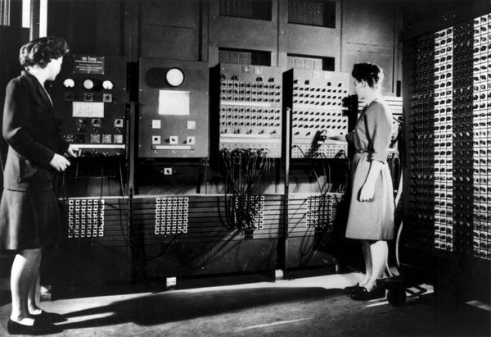

Figure Figure 1 The ENIAC released in 1946

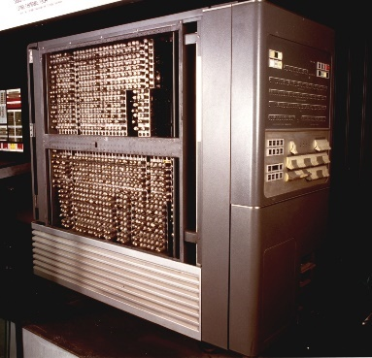In 1954, IBM introduced the IBM 704 computer, a machine based on vacuum tube technology with floating-point arithmetic hardware (IBM, 1954). Little did IBM know; this computer would serve as the platform for developing the first neural network capable of learning akin to the human brain.

Figure IBM704 Computer

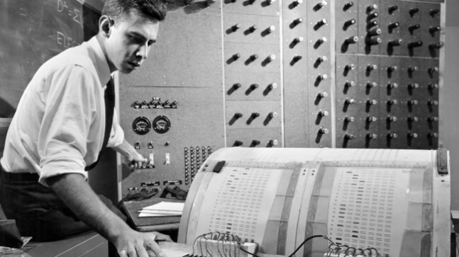

Figure Frank Rosenblatt with The Perceptron

Frank Rosenblatt, an experimental psychologist, and computer scientist utilized the IBM 704 in 1958 to pioneer a revolutionary technology named “The Perceptron” (Lefkowitz, 2019). Widely acknowledged as the first instance of artificial intelligence, the Perceptron was a binary classifier designed to distinguish the gender of individuals from given input pictures. This ground-breaking technology set the stage for future advancements and became the bedrock upon which the AI colossus would rise.

### Deep Learning

As the years progressed, the AI landscape evolved dramatically. Deep learning, a subset of machine learning, emerged as the vanguard of AI development. This development drew inspiration from Frank Rosenblatt's pioneering work with the Perceptron model. Deep learning employed multi-layered neural network models, including input, output, and hidden layers, designed to emulate the intricate structure and function of the human brain. With the ability to learn from vast amounts of data, these multi-layered models evolved beyond the Perceptron’s binary classification to manage more complex non-linear tasks, thereby overcoming the constraints of Rosenblatt’s original model. The learning mechanism employed for training these models reflected the human learning process, utilizing techniques such as backpropagation and derivative loss calculations to adjust the weights in the model, thus minimizing the discrepancy between predicted and actual outputs.

With the transition from rule-based to data-driven systems, artificial intelligence could learn and apply its learning to an unprecedented array of tasks. This included language translation, image recognition, and the generation of realistic, human-like text. Integrating this concept into the realm of 3D animations summarizes the entire dissertation.

### Generative-AI for 3D Animations

The use of deep learning for generating animations is a relatively recent advancement, with significant strides being made over the last decade. In 2017, Daniel Holden, Taku Komura, and Jun Saito introduced the Phase-Functioned Neural Network for character control, a notable development. This model can generate high-quality, complex 3D character animations that adapt based on the environment.

Even though traditional animation systems still dominate the gaming and film industries, the need for cost-efficient and scalable solutions is undeniable. The average cost of producing AAA games nowadays ranges between $80 and $150 million, with a significant portion of the budget allocated to pre-production and animation (Guru Staff , 2022). This includes recording motion capture animation for cinematic and story animations and creating baked animation systems and state machines for character control and object interactions. The challenge with this approach lies in its complexity and lack of scalability. For instance, introducing a new state such as walking while injured requires the state machine manager to add a new leaf state to each state that transitions to the walking state, such as crouching to walking, falling to walking, etc.

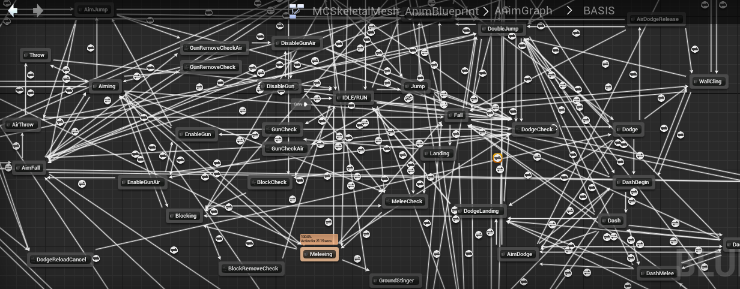

Figure State Machine Spaghetti

These costs, both financial and in terms of human labour, could be significantly reduced by deep learning animation systems, now capable of managing object interactions. An often-overlooked advantage is the continuity between cinematic and story animations with gameplay animations. Since the animation model is trained on motion capture data of actors performing, it captures subtle nuances and details typically missing from traditional gameplay animation systems.

## Objectives

The primary objective of this dissertation is to provide a comprehensive account of the development, implementation, and critical evaluation of the PFNN animation system in Unreal Engine, delving into its capabilities to generate realistic and natural character movements in real time. The project's progression is documented in a chronological manner, starting with the initial exploration of PFNN and its selection as the cornerstone for the honours project. The narrative then guides the reader through the various stages of development and refinement, addressing challenges faced, lessons learned, and key decisions made along the way. This critical evaluation explores the extent of the project's success in meeting its objectives, shedding light on opportunities for future work and innovation.

Furthermore, the dissertation discusses the most recent developments in the field of deep learning animations by presenting a thorough literature review section. This exploration not only offers valuable context for the project but also situates it within the broader landscape of research in the domain. The dissertation highlights the significance of the project and underscores its relevance to ongoing academic and industry pursuits.

## Keywords

1. Phase-Functioned Neural Network (PFNN)

2. Machine Learning (ML)

3. Exponential Linear Unit (ELU)

4. Recurrent Neural Network (RNN)

5. Mean Squared Error (MSE)

6. AdamWR

7. Stochastic Gradient Descent (SGD)

8. Neural State Machine (NSM)

9. Local Motion Phase (LMP)

10. Character Control

11. Sinusoidal Function

12. Periodic Autoencoder

13. Unreal Engine

14. Locomotion

15. Real-time

16. Motion synthesis

17. Virtual Environments

# Literature Review

The literature review section encompasses a series of research papers that contribute significantly to the progressive development of deep learning locomotion synthesis for character control. These studies aim to explore the capabilities of generative AI in real-time animation, as well as the implementation and integration of advanced neural networks, such as the Phase-Functioned Neural Network (PFNN) and the Periodic Autoencoder. The papers also demonstrate the use of these networks in different gaming and animation environments, such as Unreal Engine, and emphasize the importance of goal-driven character motion synthesis for realistic scene interaction. Moreover, they explore learning fast and dynamic character interactions by proposing new features like Local Motion Phase. The progression of research in this field showcases a continuous improvement in the capabilities and applications of deep learning techniques for character animation and control. The interrelated nature of these papers signifies the ongoing evolution of deep learning locomotion synthesis in response to the growing complexities and demands of the animation industry.

## PHASE-FUNCTIONED NEURAL NETWORKS FOR CHARACTER CONTROL (Holden, et al., 2017)

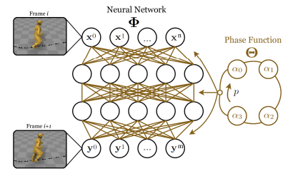

Figure PFNN Visual Diagram

### Introduction

#### Aim

The primary aim of this research paper is to test out the capabilities of generative AI in the field of real-time animation. It achieves this by implementing a novel neural network called the Phase-Functioned Neural Network (PFNN), which uses the phase a cyclical function to produce realistic animation in real-time virtual environment.

#### Objective and Scope

To evaluate the capabilities of generative AI in the field of real-time animations, the paper introduces a novel neural network structure called a Phase-Functioned Neural Network. This network can generate a continuous stream of high-quality animations in complex environments with expressive user control. The paper also outlines the procedures involved in the mo-cap data acquisition and processing for training the PFNN and generating network weights. After the weights are generated, they are used in an interactive demo, the demo uses the OpenGL graphics library for 3D rendering and the Eigen and GLM libraries for maths. The application demonstrates the capabilities of the PFNN in real-time virtual environments, the PFNN can adapt the animation over rough terrain and crouching and jumping to avoid obstacles. The paper ends by concluding that the PFNN is fast, compact, and capable of generating high-quality locomotion in a real-time environment.

### Methodology

The paper outlines 3 stages in the creation of the PFNN: Pre-Processing, Training, and Runtime.

#### Pre-Processing

The mo-cap data is captured by recording several long sequences of locomotion in a variety of gaits and facing directions, including walking, jogging, running, crouching, and jumping. These sequences also incorporate obstacles, ramps, and platforms to ensure a comprehensive range of character movements. The processing stage involves computing and manually labelling the control parameters, which include the phase of the motion, gait labels, body trajectory, and terrain height.

**Terrain Fitting**Terrain fitting is the process of fitting the terrain to the motion capture data, it is a two-stage process. Firstly, the heights and contact labels of the left and right foot joints are calculated every frame, this is done for each of the motion cycles in the database. The height of the terrain is calculated using the average position of each foot joint when they are in contact with the ground, this is then used to centre the terrain patch at the contact location. During the second stage, a Radial Basis Function (RBF) is used on the best fitted terrain patches and the terrain is edited such that the feet of the character are aligned with the ground during contact times. RBFs are used in the terrain fitting process to predict the foot position and rotation over uneven terrains and interpolate between them so that the feet are always touching the ground during contact points.

The phase variable is also computed during the terrain fitting step, it is calculated by analysing the frames in which the right foot comes in contact with the ground, for this instance the value of the phase is set to 0 and the same is done for the left foot, but the phase value is changed to , this continues until the right foot comes in contact with the ground again, the phase value is then changed to 2 , signalling a full cycle of locomotion. The results are then interpolated to fill in the in-between frames.

#### Training

After the training data is prepared, it is used to train the PFNN, it learns by adjusting its internal settings, called weights, to better predict the character locomotion. It does this by measuring the average difference between the prediction and the actual motion data, to do this, it uses a cost function (also known as a loss function). The weights are then optimized using the stochastic gradient descent algorithm with a retention probability of 0.7. The model is trained in mini batches of size 32 i.e., the input data is divided into smaller batches, each batch containing 32 samples.

**Cost Function**

The cost function is made up of 2 parts:

1. Mean Squared Error: It takes the average of the squared difference between the predicted output and the actual output, for a given input,
2. Regularization: A constant value in this case gamma which is set to 0.01 is multiplied by the sum of the squared weights. This additional parameter is added to the cost function to prevent the model parameters from becoming a NaN value (Not a number, either too big or too small).

#### Runtime

OpenGL was used during the runtime stage to visualize the results, It facilitated the real-time rendering of the player-controlled character with the generated animation in a 3D environment. The PFNN pipeline can be described as follows:-

1. Loading the weights into memory.
2. Collecting the input parameters, the input parameters consist of:
   1. User controls i.e., facing direction, movement speed, and selected gait.
   2. The previous state of the character joints.
   3. The environmental data such as terrain height/angles.
3. Feeding the input parameters into the PFNN.
4. Computing the current frame’s joint state, phase change and root movement to predict the future frame's trajectory.
5. Post-processing IK for the foot joints.

### Critical Analysis

#### Strengths

1. The PFNN's ability to generate continuous high-quality animation in complex environments.
2. Fast and compact, PFNN requires only milliseconds of execution time and a few megabytes of memory, even when trained on gigabytes of data.
3. The network uses a regression function that evolves smoothly over time.
4. Mitigates dependency on large state machines and blend trees.

#### Limitations

1. Data dependency: PFNN heavily relies on the quality and variety of the motion capture data.
2. Generalization: It cannot generate animations for character movements that are not present in the training data.
3. Integration: Integrating PFNN into the existing game engine and animation pipeline requires considerable effort.
4. Stylistic Limitations: The primary focus of the PFNN is to generate realistic animations, which are not suitable for stylized or exaggerated animations.

### Conclusion

In conclusion, the paper presents an innovative approach to animation production in video games and movies using Phase-Functioned Neural Network. The PFNN demonstrates its ability to generate high-quality, real-time animations in complex environments, providing new opportunities for the industry. Further research could explore methods to overcome these limitations, such as incorporating stylized animations and improving the integration process with existing game engines and animation pipelines.

## An improved calculation system for phase-functioned neural network and implementation in Unreal Engine (Kuang, et al., 2018)

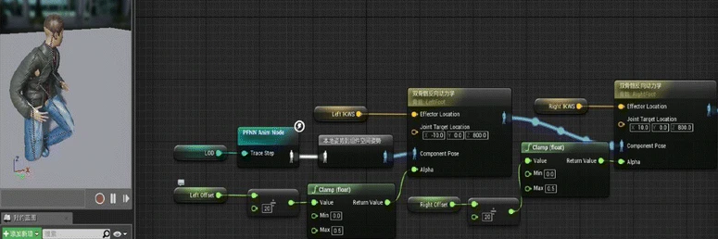

Figure PFNN setup in Unreal Engine

### Introduction

#### Aim

The primary aim of this research paper is to present a framework for implementing the Phase-Functioned Neural Network (PFNN) in Unreal Engine to generate character animations.

#### Overview and Scope

Optimizing the Phase-Functioned Neural Network to support real-time animation generation in Unreal Engine. Nvidia CUDA and parallel programming are used to improve the large prediction of matrix calculation. The PFNN prediction framework is split into two different parts: the game engine interactive layer and the prediction layer. Unreal Engine’s animation graph interface is used, and a custom animation node is created that outputs the PFNN prediction; this node can be used both in blending trees and state machines. Furthermore, the paper discusses the use of PFNN in AI NPC animations and its instancing and performance in the Unreal Engine.

### Methodology

#### Optimised PFNN Framework for Unreal Engine

The original PFNN framework is divided into two distinct components to facilitate improved compatibility with Unreal Engine.

1. **Game Engine Interactive Layer**: This layer communicates with the game engine and performs engine-specific tasks, such as
   1. Trajectory Points: Getting position direction and rotation vectors.
   2. Gait Switching: jump, crouch, walk, jog, and stand.
   3. Visual Character Mapping: maps the character in the game engine and ensures stable stimulation.
2. **Prediction Layer**: In this layer, a thread-safe PFNN prediction is made using the CUDA lock-free method. The interactive layer information is converted into a single linear vector and sent to the PFNN solver. Each animation instance is updated by calculating the trajectory using the last output parameter and the phase. This layer also does the environment query for wall and edge collision detection.

The results of the prediction layer are used in the custom FAnimNode class, which is done by overriding three functions in the class:

1. **Pre-Update**: updates the PFNN input parameters.
2. **Update**: PFNN prediction
3. **Evaluate**: Applies the predicted outcome to a skeletal mesh.

In the end, Unreal’s two-bone IK node is used to fix the foot position of the PFNN-predicted animation.

### Critical Analysis

#### Strengths

1. The use of CUDA and parallel programming increased performance from 2.0ms to 1.0-1.1ms.
2. Improved speed of matrix calculation for output prediction
3. 4-Layer architecture for Unreal Engine integration

#### Limitations

1. Long training time for the whole model.
2. The complexity in retargeting predicted output results.
3. High calculation cost, which limits the number of character instances.
4. Requires higher hardware configurations.

### Conclusion

In conclusion, the paper demonstrates the successful integration of PFNN in an industry-standard game engine, Unreal Engine. It optimizes the original paper’s matrix prediction calculation by switching from Eigen, a CPU-based math library, to CUDA, which is GPU-based. The paper also tests memory usage and performance by having 10 instances of AI and 1 player character simultaneously, and the PFNN system speed was found to be slow. To further improve the system, future research can focus on optimization techniques to enhance the performance for multiple character instances.

## Neural State Machine for Character-Scene Interactions (Starke, et al., 2019)

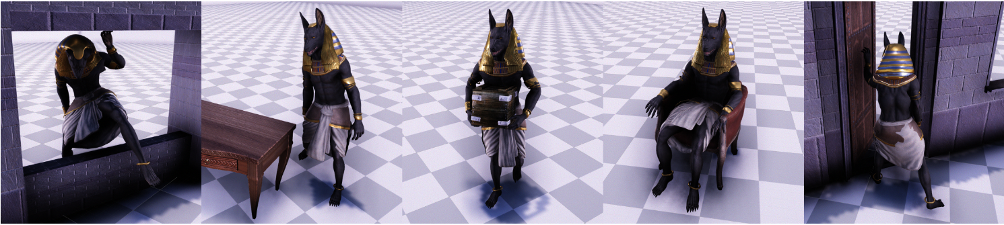

Figure Neural State Machine

### Introduction

#### Aim

The primary aim of this paper is to create and test a new data-driven framework called the Neural State Machine, which can be described as a goal-driven character motion synthesis system for realistic scene interaction in real-time applications.

#### Overview and Scope

Developing and implementing a goal-driven motion synthesis system for character control in video games, and virtual/augmented reality applications. The Neural State Machine (NSM) aims to guide characters in achieving goal-driven actions with precise scene interactions, including a wide variety of periodic and non-periodic movements such as locomotion, sitting, standing, lifting, and collision avoidance. The researchers create a multi-modal scene interaction system purely from data. This system can compute a series of movements and transitions to reach the goal in the desired state. The control scheme designed for the system incorporates both an egocentric and goal-centric interface for increased precision at runtime. The versatility of this single model is proved by the number of scene interactions it can generate in a real-time virtual environment, including interactions such as sitting on a chair, avoiding obstacles, opening and entering through doors, and picking and carrying objects. The model also generates locomotion data for different gaits.

### Methodology

There are five steps involved in creating the Neural State Machine (NSM):

1. Data Pre-Processing
2. Training the model
3. Object/Environment Fitting
4. Motion Prediction Network
5. Gating Network

Here’s a brief description of all the above steps:

#### Data Pre-Processing

In this step, the motion capture data is converted into input X and output Y.

1. **Input X**
   1. Environment Geometry
   2. Interaction Geometry
   3. Goal Inputs
2. **Output Y**
   1. Predicted Character Pose
   2. Predicted Joint Position and Rotation.
   3. Future Root Trajectory
   4. Phase Update

The dataset is also labelled with action labels, goal action labels, and phase scalars for each frame. The size of the prepared training data is 16 GB.

#### Training

Using the prepared training data, the NSM model is trained in an end-to-end fashion. Below is a list of the hyperparameters used in the training process:

* Cost Function: The Mean Squared Error (MSE) is used to measure the difference between the predicted output and the actual output.
* Optimizer: The AdamWR optimizer is used to update the model’s parameters during the training process. It is combined with the warm restart technique, which helps improve the learning process of the optimizer by resetting the learning rate periodically. This allows the optimizer to escape local minima and explore the parameter space more effectively.
* Learning Rate: Initialized with the value of $1.{10}^{-4}$, which will later decrease.
* Weight Decay rate: $2.5.{10}^{-3}$
* Number of epochs: 70
* Batch size: 32

The entire training process takes around 20 hours on an NVIDIA GeForce GTX 1080Ti GPU. After the training process, the network size is around 250 MB.

#### Object/Environment Fitting

The process of object/environment fitting involves a template object, i.e., a chair, desk, window, etc. This template object is fitted into the motion capture data by identifying the location and orientation of the object at a frame where the character body is static with respect to the object, i.e., when the character is interacting with the object. It can be anything from sitting on a chair to picking up an object. When the key joints are within a threshold distance of the surface of the template object, a contact point is embedded into the object/environment surface. Once the template object is fitted into the motion capture data, new objects are randomly sampled from ShapeNet and adapted to the pose while preserving the context.

#### Motion Prediction Network

This is the main component of the NSM. It computes the pose of the character in the current frame by using the previous frame, the geometry of the surrounding environment, and the high-level instructions, which include the goal location and the action state. The network consists of 2 modules:

1. Encoder Module: This module receives the components of the character state in the previous frame and encodes them individually using a simple three-layered network.
2. Prediction Module: This module receives the output of the encoder module and predicts the state of the character in the current frame. It also dynamically blends a group of expert weights with coefficients from the gating network.

#### Gating Network

This network uses the current state and the goal action vector as input and outputs expert blending coefficients or expert weights, which are optimized through training on a specific task or domain, i.e., walking, jogging, sitting, etc. The main objective behind this expert weight design is to increase the adaptability of the network and avoid blurry motion. The network also uses an external control variable called the “**Phase**,” which is used in a predefined cyclic function before interpolating the locomotion.

### Critical Analysis

#### Strengths

1. 16 GB motion data converted to 250 MB of weights.
2. Bidirectional control framework
3. Goal-driven character control
4. Precise scene interactions
5. Produces a wide range of periodic and aperiodic movements.

#### Limitations

1. Limited scene interactions
2. Adaptability issues with unseen geometry
3. Failure in adapting to a wider range of 3D shapes.

### Conclusion

In conclusion, the Neural State Machine research presents a novel approach to character control and motion synthesis in real-time applications. The NSM model effectively generates precise scene interactions, achieving goal-driven actions, and covers a wide range of periodic and aperiodic movements. However, it has its limitations, such as limited scene interactions, adaptability issues with unseen geometry, and failure to adapt to a more extensive range of 3D shapes.

To overcome some of the limitations in the paper, the author suggests using volume data with higher resolution and a different geometry encoder. Future work can be directed towards expanding the model's adaptability to different environments and improving its performance in handling a broader range of objects and interactions. By addressing these limitations, the Neural State Machine has the potential to become a powerful tool in character control for video games, virtual reality, and augmented reality applications.

## Local Motion Phases for learning Multi-Contact Character Movements (Starke, et al., 2020)

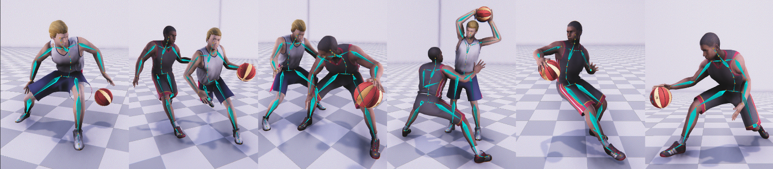

Figure Local Motion Phase Visuals

### Introduction

#### Aim

The primary aim of this research paper is to present a framework for learning fast and dynamic character interactions. It proposes a new feature called Local Motion Phase, which, when used with a mixture of expert weight architecture, can produce dynamic and fast movements that can be seen in the game of basketball.

#### Overview and Scope

Generating a large variety of fast-paced and asynchronous movements coupled with dynamic object and character interactions, as observed in the game of basketball, is possible using a new feature called Local Motion Phase (LMP). Rather than having a global temporal parameter called the phase variable like the PFNN (Holden, et al., 2017), the paper proposes a hybrid of global and local temporal parameters. The LMP is a local temporal parameter for individual joints of the body that are in contact with a 3D object, in this case, a basketball. The deep learning framework is a mixture-of-experts scheme similar to (Starke, et al., 2019). The paper also introduces a generative model that converts high-level, abstract user control signals to a wide variation of sharper, more specific control signals which can be utilized to perform realistic character movements. The local motion phase and the generative control model sum up the main enhancement proposed in the paper over other deep learning character control frameworks. The paper also introduces an automated workflow for feature extraction to reduce manual labour and avoid data inconsistency. It uses the Unity game engine to process all the motion capture data.

### Methodology

#### Data Pre-Processing and Training

The researchers use unstructured motion capture data of one-on-one basketball plays. It is during the pre-processing stage that the local motion phase is computed from the motion capture data by fitting a sinusoidal function (a function containing a sine wave) to a filtered block function, the block function represents the contact between the character’s bone and the object or environment. The fitting process uses the Root Mean Square Error (RMSE) cost function to compute the local motion phase in a fully autoregressive fashion. The local phase is then normalized by applying a Butterworth low-pass filter (removes high-frequency noise) on the original block function within a window of frames. The amplitude and maximum bone velocity parameters are then optimized within a frequency-based frame window. After optimizing these parameters, the multiple local phase variables are converted into a one-dimensional value in the context of multi-contact character movements.

The other hyperparameters used during the training process are as follows:

* Optimizer: AdamWR optimizer (Ilya Loshchilov, 2019) with the warm restart technique
* Learning Rate: $1 .{10}^{-4}$
* Weight Decay Rate: $2.5 .{10}^{-3}$.
* Dropout: 0.7

3GB of raw motion capture data is used which is then converted to ∼8GB generated training data, which is then computed to ∼24MB network weights.

#### Network Framework

The deep learning framework introduced in this paper is similar to (He Zhang, 2018) and (Starke, et al., 2019). The framework is composed of two distinct networks: the motion prediction network and the gating network, which will not be explained again as they are very similar to the ones mentioned in the “Neural State Machine for Character-Scene Interactions” paper.

The two main enhancements the paper offers are the Local Motion Phase (LMP), already explained in the pre-processing section, and a generative control model, which takes in raw user inputs and generates a much sharper variety of control signals for the model to use.

#### Generative Control Model

The control model is used to generate realistic and varied character movement animation from rough user input, i.e., a high-level input without fine details or subtle variations. The model consists of three components:

* Encoder
* Decoder
* Discriminator

Together the encoder and decoder create an adversarial network. This network creates a smoothed trajectory onto a latent space, after which it adds noise to the latent code to produce variations in the control signal during runtime. In simpler terms, it turns a simple move forward input into a more complex signal for generating realistic basketball playing animations. The discriminator distinguishes between real and generated control signals.

The model is trained to validate that the generated control signal is similar to the original but with added variation. This generated control signal is then used as input to generate a variety of realistic and fast animations with asynchronous movement of the limbs.

### Critical Analysis

#### Strengths

1. Capable of learning fast and dynamic movements during basketball play.
2. Extracts features from unstructured motion capture data.
3. Mixture-of-experts architecture for improved learning.
4. Generative control model produces a wide variation of movements from abstract control signals.
5. Allows for real-time synthesis of complex interactions between the character and the ball or with another character.
6. Potential to extend the local phase definition to non-contact movements.

#### Limitations

1. Current definition of the local motion phase is based on contacts.
2. Long turnaround time after making changes.
3. Challenges in utilizing LSTM models for interactive character control.
4. Challenges in tuning meta parameters.
5. Low responsiveness in character control.

### Conclusion

In conclusion, this research paper presents a novel framework that utilizes the Local Motion Phase and a generative control model to enable fast and dynamic character interactions, particularly in the context of basketball gameplay. The framework demonstrates the ability to learn complex movements and generate a wide variety of animations in real-time. Despite some limitations, such as the current reliance on contact-based local motion phase definition and challenges with LSTM models, the proposed framework offers significant advancements in character control and real-time synthesis. Future work can focus on extending the local phase definition to non-contact movements and improving the responsiveness and controllability of the character for interactive applications.

## Deep Phase: Periodic Autoencoder for Learning motion Phase Manifolds (Starke, et al., 2022)

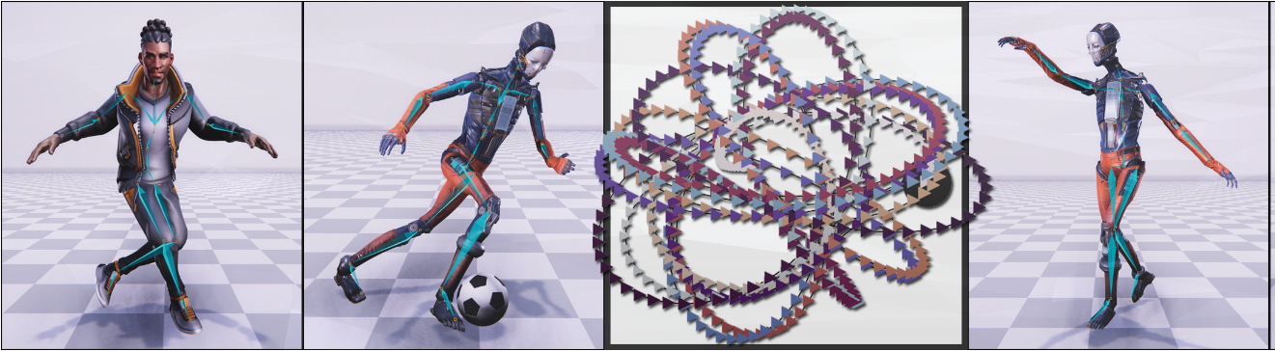

Figure Periodic Autoencoder Visual

### Introduction

#### Aim

The primary aim of this research paper is to present the Periodic Autoencoder, a novel neural network architecture that learns periodic features from massive, unstructured motion datasets without any human supervision. The research paper demonstrates the application of the periodic autoencoder in various character animation tasks, including real-time synthesis of different locomotion abilities, stylized movements, dance motion synthesis, and football dribbling.

#### Overview and Scope

Understanding and modelling the spatial-temporal structure, which refers to the relationship between the position of individual joints in motion space at any given time. There is a need for advanced techniques to learn and represent the underlying structure of the motion space effectively, which motivates the research presented in this paper.

The Periodic Autoencoder proposed here breaks down character movements into several separate components, each representing the repeating patterns of different body parts during various types of movements over time. These components, known as latent channels, help to capture the intricate details of the motion. The method then creates a multidimensional map, called a phase space, from the full-body motion data. This phase space organizes the animations into groups and results in a structure that better aligns the movements in terms of both time and space. This new technique of pre-processing motion data improves the animations in diverse locomotion generation such as stylized movement, dance motion synthesis from music, and football dribbling.

### Methodology

A temporal convolutional autoencoder architecture is used to transform the motion data into the phase manifold. This architecture is inspired by (Daniel Holden, 2015). The model not only reconstructs the input but also enforces each channel of the latent space to be in the form of a periodic function. This is done by parameterizing each latent curve as a sinusoidal function defined by amplitude, frequency, offset, and phase shift parameters. By doing this, it allows the model to calculate a phase variable for each latent channel from a small set of parameters.

#### Periodic Autoencoder Network

The Periodic Autoencoder computes the periodic latent vectors from the motion capture data and creates the phase manifold. Below is a brief description of the network structure, the phase manifold, and the training process.

#### Network Structure

The network structure can be divided into two components:

1. Encoder: It takes the 3D joint velocity trajectory as input data and transforms it into a lower-dimensional latent space using two convolutional layers. These layers are followed by batch normalization and a tanh activation function. The encoder helps create a compact representation of the input data.
2. Decoder: The decoder works to reconstruct the original input data from the lower-dimensional latent space produced by the encoder. It uses two convolutional layers, with batch normalization and tanh activation applied only after the first deconvolution. The decoder maps the latent space back to the original data format, allowing the network to compare the reconstructed data with the original input.

#### Training

The hyperparameters used during the training process are as follows:

1. Optimizer: AdamW optimizer (Ilya Loshchilov, 2019)
2. Cost Function: Mean Squared Error (MSE)
3. Learning rate: 10^-4
4. Weight decay: 10^-4
5. Batch size: 32
6. Number of epochs: 30
7. Number of phase channels: 5-10, depending on the variety of motions in the data

An NVIDIA RTX 3080 GPU is used for the training process. The training time typically takes less than an hour for smaller datasets which have approximately 1 hour of motion data and 24-character joints. However, the training time may take longer if the dataset or the number of joints becomes larger.

### Critical Analysis

#### Strengths

1. Learns periodic features from large unstructured motion datasets in an unsupervised manner.
2. Decomposes character movements into multiple latent channels, capturing non-linear periodicity of different body segments.
3. Extracts a multidimensional phase space that effectively clusters animations and improves temporal and spatial alignment.
4. Enhances neural motion synthesis across diverse tasks, such as locomotion skills, style-based movements, dance motion synthesis, and football dribbling.
5. Facilitates motion query for matching poses within large animation databases.

#### Limitations

1. The learned phase manifold does not resolve ambiguity about which motion skill to generate.
2. The dance motion synthesis system cannot combine dance movements given novel music and only aligns input music with corresponding dance motion data.
3. Learned spatial-temporal embeddings may not be suitable for more complex tasks.
4. There may be a need to combine spatial-temporal embeddings with semantic embeddings for better performance.

### Conclusion

In conclusion, the Periodic Autoencoder presents a novel approach for learning periodic features from large, unstructured motion datasets without human supervision. By decomposing character movements into latent channels and creating a multidimensional phase space, the technique effectively clusters animations and improves temporal and spatial alignment. The proposed method shows promise in enhancing neural motion synthesis across various tasks and facilitating motion query within large animation databases. Despite its limitations, the Periodic Autoencoder provides a valuable contribution to the field of deep learning generative animation and opens up new possibilities for future research in understanding and modelling complex motion data.

# Methodology

The methodology section provides a comprehensive overview of the approach taken throughout the project, highlighting the different timelines and the evolution of the project from its inception to completion. The process began with the selection of the honours project and progressed through various stages, including proposal writing, feasibility demo, and the eventual development of the Project Artefact, which showcases the use of the PFNN animation system in Unreal Engine. Every stage of the methodology is discussed thoroughly, emphasizing the obstacles encountered, the knowledge gained, and the choices made. This section is arranged in chronological order, starting with September, and progressing until May.

## September

During the process of selecting an honours project, a PFNN demo video was discovered on YouTube (Yoshiboy2, 2017). This video showcased an impressive technique that had not been seen before. Upon further investigation, it was found that the PFNN research paper was published in 2017 and that the field of deep learning had significantly advanced since then, with concepts like DeepPhase and Local Motion Phases emerging. Ultimately, PFNN (Holden, et al., 2017) was chosen as the foundation for the project due to its simplicity compared to the latest papers in the field and feasibility within the given time frame for the honours project. After selecting the research paper, the project choice document was submitted on the 30th of September 2022.

## October

The project proposal was submitted on the 18th of October 2022. Looking back, it was significantly different from the finished product. The aim of the proposal was to "Create an application to test the possibility of implementing a Phase-Functioned Neural Network to produce natural and realistic-looking animation for character control in real-time." Feedback on the proposal indicated that it focused too much on recreating published work without adding anything new.

## November

A feasibility demo was submitted on the 29th of November 2022, showcasing an understanding of the PFNN research paper along with some implementation code. The feedback was similar to that of the project proposal, suggesting that the project could benefit from a more critical evaluation of prior work and more original and creative inquiry, meaning that the project was still a mere recreation of the original paper without added improvements.

## December

During this time, two other ongoing modules, CMP407 (Audio Programming) and CMP404 (AR), were undertaken, both of which directly or indirectly used Unreal Engine for the final submission. This was not the first time Unreal Engine was used in the university curriculum, as the third year DES310 Professional Project and CMP302 Gameplay Mechanics Development modules were also completed in Unreal Engine. After reviewing the feedback on both the project proposal and the feasibility demo, the decision to recreate the PFNN paper in Unreal Engine was made and communicated to the project supervisor during the last meeting before the Christmas break.

## January

Throughout the Christmas break, a considerable amount of time was spent learning Unreal Engine's animation systems. Although there was previous experience with Unreal Engine, the animation system was largely an unexplored territory. To facilitate the learning process, a procedural animation system was developed for a quadruped gecko. The gecko model was originally created for the DES310 Professional Project, with the 3D artist, Kyle (Third, n.d.), designing the model and the animator, Jason (Beggs, n.d.), handling the rigging.

The following sections provides a detailed explanation of the procedural animation system.

### Procedural Animation System

The procedural animation system utilises Unreal Engine's Control Rig system in conjunction with the Full Body IK node. The procedural animation video published on Unreal Engine’s YouTube channel (Unreal Engine , 2022) was a big help towards creating this system.

#### Control Rig

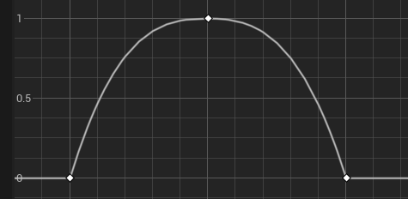The first step was to create a control rig using the Unreal Engine control rig system. Then, bone controllers were added to each foot to enable manipulation and transformation of the bone based on external data.

Figure Float Curve

#### Feet Position and Full body IK

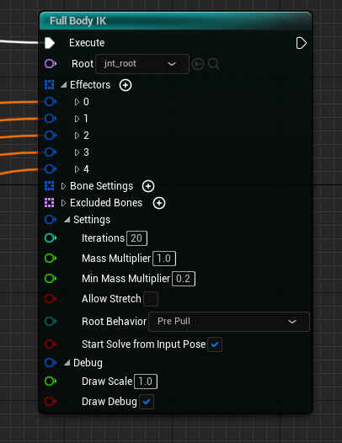The next significant step was to calculate the feet's position, which was done using four-line traces projected downwards from the gecko's feet. When the gecko moved beyond the threshold step distance, a step position was calculated using a float curve. This caused the gecko's feet to move in an arc and land on the new step position, which was directed to the control rig. The control rig used a Full Body IK node with five effectors, including four for each of the feet and one for the head. The feet position calculated was first converted to local space and then applied to each of the foot controllers' transformation.

Figure Full Body IK node

The Full Body IK node in Unreal Engine works by calculating the position of each bone in the body based on inverse kinematics algorithms. For instance, when any of the controller attached to the four feet bones is moved, the node calculates the position for each bone in the body. This algorithm enables the animation system to generate realistic character animations, which can be further improved using other animation tools, such as motion capture and procedural animation.



Figure Full Body IK Control Rig

#### A screenshot of a computer Description automatically generated with medium confidencePost Process Animation

Figure Post Process Animation Blueprint

In order to enhance the believability and fluidity of the gecko's movements, a post-process animations blueprint was applied to the skeletal mesh. The blueprint serves as a critical component in creating a lifelike digital representation of a gecko, as it layers multiple animations, infuses physical simulations, and adjusts body parts as per the demands of the environment and the animation.

The post process animation blueprint functions by caching different animation poses. This allows the blueprint to seamlessly layer multiple animations which contributes to the overall realism of the gecko’s behaviour.

Below is a table encompassing the different layers of animation applied to the gecko:

|  |  |
| --- | --- |
| Tail Physics | Uses the Rigid body node in Unreal Engine, which simulates real-time physics using the bone weights |
| Tongue Physics | Uses the Rigid body node and bone weights as well |
| Spine Adjustment | Uses a control rig to manipulate the angle of the spine joints by performing a downward line trace to detect the angle of the surface below |
| Eye Movement | Uses a control rig to move both the eyes of the gecko, the eyes move based on a set timer inside the control rig. |

#### Final Product

This is what the final product looks like,

Figure Procedural Animation in Unreal Engine

|  |  |
| --- | --- |
| Red Squares | The hit location of the line traces |
| Green Diamonds | New Foot position |
| Yellow Diamonds | Old Foot Position |

## February-May (PFNN Implementation)

The commencement of February marked the initial steps towards integrating the PFNN into Unreal Engine. The final implementation is a blend of the (Holden, et al., 2017) and (Kuang, et al., 2018) research papers. It employs the same libraries used in the (Holden, et al., 2017) paper, specifically Eigen and GLM. However, unlike the original paper's implementation, which was confined to a single CPP file, it subdivides the implementation into multiple classes and structures. This approach enhances the project's structure and compatibility with Unreal Engine’s C++ framework. The project then leverages the UAnimNode_Base and UAnimGraphNode_Base method described in the (Kuang, et al., 2018) paper.

### External Libraries

Accessing the libraries used in the original paper required the creation of an UPlugin, as this is the only method to incorporate external libraries in Unreal Engine. The motive behind using these libraries was to accurately replicate the paper's content. Once the plugin was operational, the subsequent step involved defining the class structure for the plugin.

### Class Structure

The above UML diagram was made to better understand and explain the class structure, the diagram shows the classes made and the relationship between these classes in Unreal Engine for character animation. Each part of the original paper was divided and implemented into its own separate class.

#### Core

The core folder in the plugin consists of two classes:

**PFNN_Character:** Derived from ACharacter, this class handles camera positioning, processes user input for character movement and camera control, and manages character trajectories. Functions such as 'OnJogPressed', 'OnCrouchPressed', etc., handle specific user interactions for changing the gait of the PFNN animation.

**PFNN_GameInstance:** Derived from UGameInstance, is the initial class invoked when Unreal Engine executes the program. It's primarily utilized to load PFNN weights asynchronously into memory. This operation is accomplished using a PFNNDataContainer class object in conjunction with the StartBackgroundTask function of the FAutoDeleteAsyncTask structure, thereby enhancing the program's efficiency and cohesiveness.

#### Animation

This folder contains most of the classes for the PFNN calculations and application.

**Trajectory Component:** DerivedfromUActorComponent, this class calculates the trajectory of the player character by using the direction and velocity of the character in the game. It converts the character's forward vector to a normalized direction, then applies a rotation. It then calculates the target velocity based on the character’s current speed and desired direction. It then uses a linear interpolation ("mix") to gradually adjust the velocity and direction over time, providing smooth movement. Additionally, it handles strafing movement by adjusting the target direction based on a strafing amount.

The trajectory transform data is stored and manipulated using these variables.

    glm::vec3 Positions[LENGTH];

    glm::vec3 Directions[LENGTH];

    glm::mat3 Rotations[LENGTH];

The **predict future trajectory** function in the class, calculates the future trajectory of the character by setting a trajectory midpoint, then calculating the future positions and directions by interpolating between the current and target states while maintaining trajectory heights and gaits (standing, walking, etc.) consistent with the midpoint. The function updates the original future positions with the newly computed ones, ensuring a natural and smooth transition in the character's movements.

The class includes a function that logs all the generated data into a text file. This text file can be viewed in the demo application by navigating to the UE5_PFNN fold.

**PFNN_AnimInstance:** Derived from UAnimInstance, this class is used as the parent class for the character animation blueprint to access the custom PFNN animation node created for this plugin. It also provides a the updated trajectory to the anim node class.

**AnimNode_PFNN:** Derived from FAnimNode_Base, this class handles majority of the calculation for the PFNN animation system. The class overrides 3 functions similar to the (Kuang, et al., 2018) paper. The class also includes a function that logs all the generated data into a text file. This text file can be viewed in the demo application by navigating to the UE5_PFNN folder.

* ***Initialize_AnyThread*:** Thisfunction initialises the node and gets the AnimInstanceObject from the PFNN_AnimInstance class.
* ***Update_AnyThread*:** This function checks whether the PFNN weights have been loaded correctly and retrieves the updated trajectory component from the PFNN_AnimInstance class. If the data and trajectory parts are processed successfully, it applies the PFNN calculation.
* ***Evaluate_AnyThread:*** This function applies the predicted bone rotation and location to the skeletal mesh assigned in the character class. Before applying, it creates two transforms for the child and parent bone, using these two transform it creates a relative transform which is the local transform and this local transform is then applied onto individual joints, except the first bone and the root bone.
* ***ApplyPFNN*:** This function calls the TickTrajectory() to update the trajectory data, then sends this data to the input layer of the PFNN. Because the original paper used the OpenGL framework (which is Y-axis up) and Unreal Engine is Z-up, the trajectory data is translated to the OpenGL format. Once the input layer is initialized, the predict function is called with the phase value as a parameter.
* ***Phase:*** This variable calculates the weighted average of the movement, multiplies it by 2π, then checks if the calculated value falls within the range of 0 to 2π.
* ***Predict():*** Part of the Phase-Functioned Neural Network class, this function predicts the joint transforms in three modes: constant, linear, and cubic. After the prediction process is completed, a local transformation of the joint is created from the predicted output. This is then used to update the current and future trajectory of the character controller. The predicted output is then transformed back into the Unreal Z-up format and is stored inside the FinalBoneLocation and FinalBoneRotaion arrays.
  + ***Constant:*** In this mode, it calculates the index based on the phase input and uses this index to extract the appropriate weights and biases for the neural network. It then computes the forward pass through the neural network with ELU (Exponential Linear Unit) as the activation function.
  + ***Linear:*** In this mode, it calculates two indices based on the phase input, and a proportion amount. It then linearly interpolates the weights and biases between these two indices using the proportion amount. The neural network computations are then performed like the first mode.
  + ***Cubic:*** In this mode, it calculates four indices and a proportion amount. It then performs cubic interpolation on the weights and biases using these indices and proportion amount. After that, it performs the neural network computations like the previous modes.

**PFNN:** The PFNN folder contains the Phase-Functioned Neural Network class and the PFNN Data Container class.

**PhaseFunctionNeuralNetwork:** Derived from the UDeveloperSettings, this class contains the PFNN model, following are the hyperparameters used in this model.

* **XDIM:** This represents the dimension of the input data. It is set to 342 in the code.
* **YDIM:** This represents the dimension of the output data. It is set to 311 in the code.
* **HDIM:** This represents the dimension of the hidden layers. It is set to 512 in the code.
* **Xmean:** This is the mean of the input data used for normalization during the training of the PFNN.
* **Xstd:** This is the standard deviation of the input data used for normalization during the training of the PFNN.
* **Ymean:** This is the mean of the output data used for normalization during the training of the PFNN.
* **Ystd:** This is the standard deviation of the output data used for normalization during the training of the PFNN.
* **W0, W1, W2:** These are the weight matrices of the PFNN between the different layers (input to first hidden layer, first hidden to second hidden layer, and second hidden layer to output layer, respectively).
* **b0, b1, b2:** These are the bias vectors of the PFNN for the first hidden layer, second hidden layer, and output layer, respectively.
* **Xp:** This is the input data for a single frame of the animation.
* **Yp:** This is the output data for a single frame of the animation.
* **H0, H1:** These are the hidden layer activations for the first and second hidden layers, respectively.
* **W0p, W1p, W2p:** These are the weight matrices for the prediction part of the PFNN between the different layers (input to first hidden layer, first hidden to second hidden layer, and second hidden layer to output layer, respectively).
* **b0p, b1p, b2p:** These are the bias vectors for the prediction part of the PFNN for the first hidden layer, second hidden layer, and output layer, respectively.

From the above parameters, the PFNN has three layers: an input layer with 342 nodes, a hidden layer with 512 nodes, and an output layer with 311 nodes.

**PFNN_DataContainer:** Contains 3 different classes.

* PFNN_DataContainer: Contains most of the functions and variables for loading network weights, including mutex for locking the thread.
* PFNN_DataLoader: Is derived from FNonAbandonableTask class in unreal engine and uses the DoWork() to load network data, an FNonAbandonableTask is a type of task that represents work that cannot be abandoned once it has started executing.
* PFNN_WeightLoader: Is also derived from FNonAbandonableTask and in the DoWork() it checks if the both the delegates are still bound or being used, if not then the weights are loaded

**AnimGraphNode:** The visual representation of the AnimNode_PFNN class in the animation graph blueprint editor.

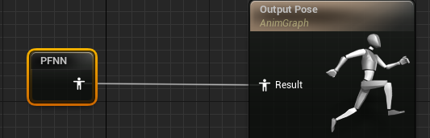

Figure PFNN node in the AnimGraph

# Results

Below are the results of the implementation, with some performance testing data compared to the original paper, keep in mind that the hardware specifications used in the original paper are much lower than what this project has used.

**Original Paper**

**CPU:** Intel i7-6700 3.4GHz

**GPU:** NVIDIA GeForce GTX 660.

**Honours Project**

**CPU:** Intel i7-9750H CPU @ 2.60GHz

**GPU:** NVIDIA GeForce RTX 2060

## PFNN Results

The PFNN animation system can produce animations in three different states, these are:

  
Crouching Walking Jogging

The system smoothly blends between these states, for example, the system can blend between the crouching and jogging state, creating a new gait “Crouched Jogging” even though the dataset it was trained on never included a motion capture for such movement.

## Performance

Due to the use of threads in the loading process, the weight loading time during run-time has gone down significantly compared to the original paper,

| **Technique** | **Training** | **Runtime** | **Memory** |
| --- | --- | --- | --- |
| UE5-PFNN-cubic | 30 hours | 0.0014s | 15 MB |
| UE5-PFNN-linear | 30 hours | 0.0010s | 30 MB |
| UE5-PFNN-constant | 30 hours | 0.0004s | 150 MB |

| **Technique** | **Training** | **Runtime** | **Memory** |
| --- | --- | --- | --- |
| PFNN-cubic | 30 hours | 0.0018s | 10 MB |
| PFNN-linear | 30 hours | 0.0014s | 25 MB |
| PFNN-constant | 30 hours | 0.0008s | 125 MB |

1. **Runtime**: The UE5 implementation of PFNN shows a decrease in runtime across all techniques (cubic, linear, constant) compared to the original PFNN. This suggests that the UE5 implementation is more efficient in terms of computation speed.
2. **Memory**: On the other hand, the memory usage in the UE5 implementation is higher for all techniques. This could be due to the additional overhead of the Unreal Engine, which may require more resources to execute the same tasks.
3. **Training Time**: The training time remains constant at 30 hours for all techniques in both implementations. This indicates that the transition to UE5 does not affect the time required to train the models.

Even though the project seemed to be performing at a good frame rate with low loading times there are still major limitations to the project, these are discussed in the section below.

# Discussion

This section discusses the challenges encountered during the development of this project and critically evaluates the final artefact.

## CHALLENGES FACED

The project began with the proposal to train the network and then implement the interactive demo using the trained weights in OpenGL. However, this plan did not contribute anything new to the original paper and merely replicated it.

Once the decision to recreate the paper in the Unreal Engine was made and communicated to the supervisor, learning the Unreal Engine animation system began. This process resulted in the gecko quadruped procedural animation system, which utilizes the Control Rig component of the Unreal Engine. The process of creating this animation system was intuitive since most of the work was done using Unreal Engine’s visual scripting language, "Blueprints". The system was implemented in blueprints for faster iterations and implementation compared to C++.

During the implementation of the PFNN into the Unreal Engine, it was discovered that the PFNN could only produce animation for 31-Character joints, as shown in Appendix 11.3. To accommodate this requirement, a test character mesh was created despite a lack of prior modelling or rigging experience. The test mesh was then rigged with the appropriate joint hierarchy. The weight painting process was skipped due to lack of experience in that division of rigging and because it wasn't mentioned in the original paper.

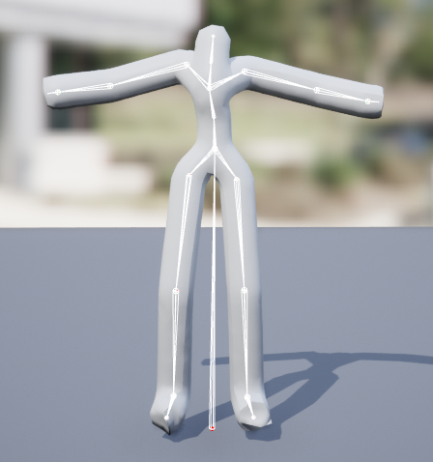

Figure Test Mesh with 31-Joints

When the mesh was integrated into the engine, the mesh deformed and stretched the bones, increasing their size by 20 times. The cause of this was unknown at that time.

To investigate the mesh deformation problem, all the joint transform data were logged. The observed trends in the predicted joint transforms are as follows:

* The rotational values (X, Y, Z, W) indicate the orientation of the joints in the 3D space. The W value, representing the scalar part of the quaternion defining the rotation, fluctuated between -1.5 and 3.5. To normalize this fluctuation, the arg_Output.Pose.NormalizeRotations() function was used, stabilizing the values between 0.87 and 0.89.
* A comparison of the joint transform data with the original paper's prediction data revealed that the Y and Z values of the joint positions were interchanged. This was due to Unreal Engine using a Z-Up framework compared to OpenGL’s Y-Up. To mitigate this, a new class "PFNN_HelperFunction" was created (see Appendix 11.4). This class converts a 3D vector coordinate system between XYZ and XZY, performing this conversion both from and to the glm::vec3 and Unreal's FVector.
* The joint transform data was directly applied to the mesh, as local bone transformation was done during the prediction process. However, the joint transformations were not relative to the parent bones because the transformation process didn't utilize the bone hierarchy and instead transformed all the bones based on the root bone. To ensure that local bone transformation was done correctly, two transforms were created using the FCompactPoseBoneIndex structure (FTransform ChildBoneTransform and FTransform ParentBoneTransform). These were then used to get the relative transform, see appendix 11.5 for more detail.

At this point, the mesh was still deforming, but the height of the mesh was stable. During the investigation into the deformation problem, it was found that the physics asset associated with the mesh only had two bones, the root and spine. It seemed that the bone weights were not being set correctly in the physics asset, causing an improper weight distribution. As a result, when the bone location and rotation were applied to the mesh, it collapsed due to this improper weight distribution (Fig. 17).

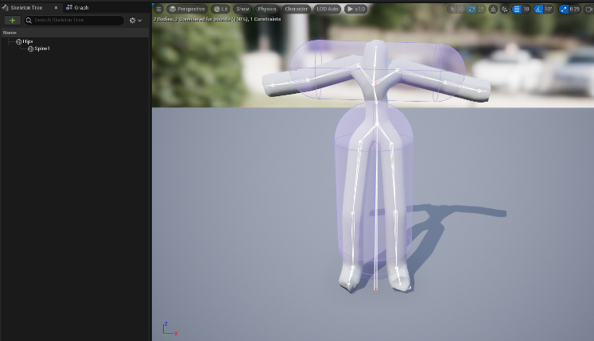

Figure Physics Asset PFNN

The hypothesis regarding the cause of the mesh deformation was communicated to the supervisor the same day. Assistance was requested from animation professor Lynn Love to help with the weight painting and skin binding process. Due to Professor Lynn Love's busy schedule, she was unable to provide assistance. However, Jason Beggs, one of her former students and the animator from the DES310 group, was willing to help with any questions regarding the rigging process and the software Maya.

With Jason's help, Unreal Engine's default mannequin mesh was rigged and skin-bound using the 31-Joint hierarchy. This process involved rigging the mesh and fixing the local rotation axis for each joint. After this, the joints were skinned to the mesh, and the weight painting process began. Weight painting is a highly visual process, as illustrated in Fig. 18. The red areas indicate where the majority of the weight is concentrated, with yellow and blue representing the weight fall off for a smoother blend between the joints. The deformed part of the mesh is due to improper weight paints.

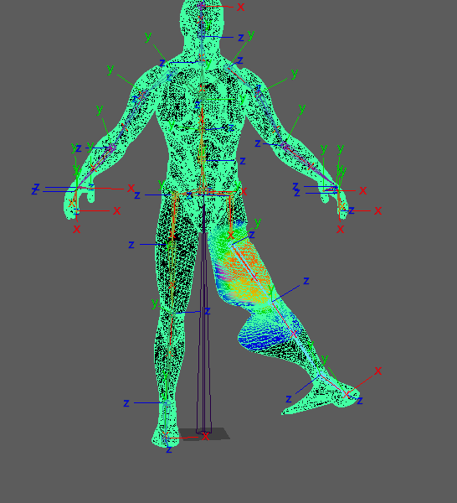

Figure Weight Painting

Once the rigging and weight painting were complete, the final model appeared as in Fig. 19.

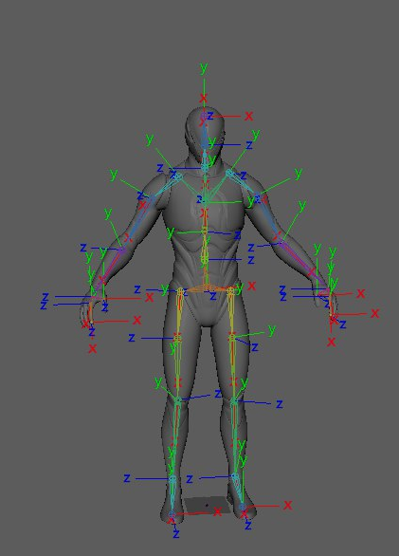

Figure UE5 Manny Rigged with 31-Joint hierarchy.

However, after implementing the newly weight-painted model into the PFNN, the mesh deformation problem persisted. To address the mesh deformation, another approach was used to apply joint transforms to the mesh. This involved using the control rig with the full body IK node, similar to the procedural animation system for the gecko.

Multiple bone controllers were created for each joint in the body.

|  |  |
| --- | --- |
| Red Balls | Represents the left leg and arm controllers. |
| Green  Balls | Represents the spine, neck, and head controllers. |
| Blue  Balls | Represents the right leg and arm controllers. |

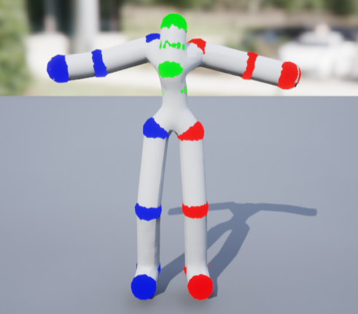

Figure PFNN Control Rig

Once the control rig was set up, all joint rotation data was transferred via the character class to the post animation blueprint. This was done so that the main animation blueprint could calculate all required joint transforms without applying it to the mesh, and those transforms could be applied to the control rig via the post animation blueprint.

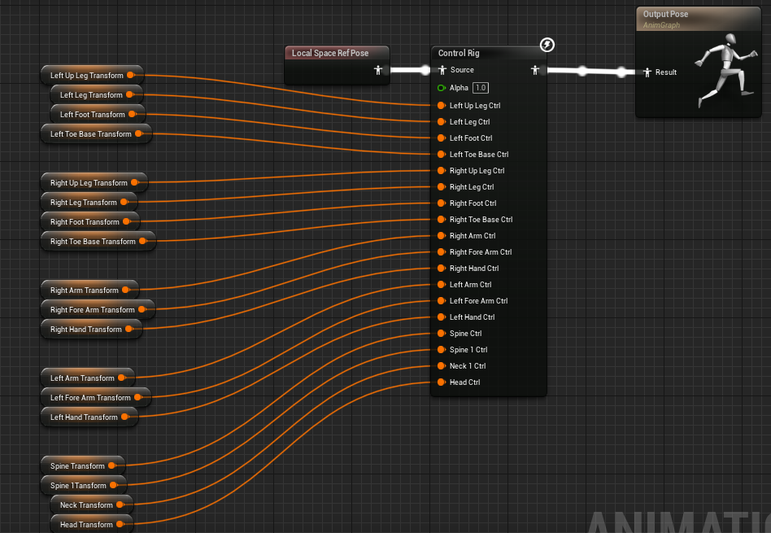

Figure PFNN Post Animation Blueprint

The result of this fix was that the joint transformation was not applied correctly and was constantly fluctuating. While investigating this fluctuation, it was discovered that the future trajectory of the PFNN was not being predicted. This can be seen in the following GIF where debug points are projected onto the position of the predicted trajectory.



Figure Trajectory Issue

Unfortunately, due to the late discovery of this issue (on the day of submission), it could not be resolved for the project artefact.

On the submission day, the Unreal Engine project could not be packaged due to errors related to the use of the UnrealEd module in a non-editor target. This was because the AnimGraphNode class was part of the same plugin module, i.e., the run-time plugin module, which cannot be used for non-editor targets, such as a packaged game. To resolve this error, a new module was created in the plugin, which only contained the AnimGraphNode class. The build.cs file for the module can be found in Appendix 11.1 and the uplugin config file in Appendix 11.2.

During the project packaging, the Eigen library threw a warning labelled 'nodiscard attribute', which was treated as an error. To resolve this, the warning was disabled in the plugin's build files (PFNN.Build.cs and PFNNEditor.Build.cs). The following lines were added to exempt these warnings from being treated as errors.

*if* (Target*.Platform* == UnrealTargetPlatform*.Win64*)

        {

            // *Disable the warning for discarding the return value of a function with the 'nodiscard' attribute*

            PublicDefinitions*.Add*("_SILENCE_CXX17_RESULT_OF_DEPRECATION_WARNING");

            PublicDefinitions*.Add*("EIGEN_MPL2_ONLY");

            // *Enable exception handling*

            bEnableExceptions = true;

        }

## Critical Evaluation

The development of this project offered a significant exploration of the challenges and opportunities that arise when implementing the PFNN into the Unreal Engine.

Firstly, the decision to shift from OpenGL to Unreal Engine marked a pivotal moment in the project’s trajectory. This shift, while ambitious, brought with it a unique set of challenges, particularly in understanding and manipulating the Unreal Engine’s animation system. The gecko procedural animation system showcased Unreal Engine’s capabilities in producing expressive animations in a real-time virtual environment.

The PFNN implementation still suffers from the mesh deformation issue, and it’s challenging to pinpoint what is causing this problem. Even when it was discovered that the trajectory prediction was incorrect, the mesh deformation wasn't directly related to that, as this shouldn't impact how the bones are being transformed inside a mesh. One hypothesis might be related to how Unreal Engine manages the custom animation nodes, but without a deeper understanding of Unreal’s inner workings, this remains speculative. Another reason that maybe causing the trajectory to be unstable is that the conversion between the XZY and XYZ coordinate system might have some underlying effect to the way trajectory is applied in unreal engine.

Apart from the mesh deformation and incorrect trajectory prediction, the project still provides a valuable steppingstone for anyone looking to delve into deep learning animations. As the project files and the GitHub repository (utkarshyadav009, 2023) have been made public, those interested in creating something similar will find these resources helpful. The plugin created could also be published on Unreal’s marketplace for easier access to the work done.

Due to the mesh deformation problem, it's tough to say that the aim of this project was successfully achieved. However, the project presented a valuable learning experience and a strong foundation for future work. The challenges faced and the lessons learned can guide the next steps and contribute to further refinement of the animation system. Despite the hurdles, the project showcases resilience, adaptability, and commitment to innovation, hinting at potential for future success.

# Conclusion

The experience I had during the honours project was unlike any other. As my 4th year was about to start, I found myself at a crossroads. I couldn't decide whether to dive deeper into academia and pursue an honours degree, or just wrap up with a normal BSc degree and start hunting for a job. I was honestly weary of the academic grind—the constant deadlines, the endless report writing, and the little freedom I had when it came to choosing a project. Despite all these doubts, I decided to pursue my 4th year, though I carried some reservations with me. But something transformative happened during 4th year that changed my opinion on academia, the honours project gave me the freedom to choose a project in a field that I was passionate about, even though the final artefact is still miles away from what was promised in the aim, I am still proud of what I was able to achieve in the given time frame.

To further examine the project, after I submitted the artefact, I found out about an experimental plugin by Unreal Engine called “Motion Trajectory”, this plugin is designed to compute the trajectory prediction of the character within a virtual environment. This might be a possible solution to the incorrect trajectory prediction problem that the project suffered from. This plugin is specifically being used for another animation technique called “Motion Matching”, which rather than producing its own animations using weights, blends the most appropriate animation clips from a large database, based on the character's movement trajectory. An additional enhancement that could benefit the project is eliminating the dependency on external libraries. During the PFNN implementation, I discovered that many functions offered by these libraries had Unreal Engine equivalents, by using the built in maths library of unreal any conversion or built error can be mitigated.

In Conclusion, I am grateful that I came to finish my 4th year at Abertay as it rejuvenated my hunger for learning and changed my opinion towards academia This concluding section may well be my last as a student at Abertay. Therefore, I take this opportunity to express my gratitude towards the University of Abertay and the city of Dundee for their kindness and support. Upon my arrival in Dundee in 2019, I was as lost as any 17-year-old, I didn’t understand myself and my own capabilities as a programmer, but during these four years I have discovered my potential. Perhaps that's why they call Dundee "The City of Discoveries".

# References

Beggs, J., n.d. [Online]   
Available at: https://vimeo.com/user107903953

Brockmeier, E. K., 2021. *The world’s first general purpose computer turns 75.* [Online]   
Available at: https://penntoday.upenn.edu/news/worlds-first-general-purpose-computer-turns-75  
[Accessed 10 May 2023].

Daniel Holden, J. S. T. K. T. J., 2015. *Learning motion manifolds with convolutional autoencoders.* [Online]   
Available at: https://dl.acm.org/doi/10.1145/2820903.2820918  
[Accessed 10 May 2023].

dmji, 2022. *PFNN-UE5-Implementation.* [Online]   
Available at: https://github.com/dmji/PFNN-UE5-Implementation/tree/ai4animation  
[Accessed 23 January 2023].

GDC, 2018. *Character Control with Neural Networks and Machine Learning.* [Online]   
Available at: https://www.gdcvault.com/play/1025389/Character-Control-with-Neural-Networks  
[Accessed 15 November 2022].

Guru Staff , 2022. *What Is the Average Cost of Game Development?.* [Online]   
Available at: https://www.guru.com/blog/what-is-the-average-cost-of-game-development/  
[Accessed 14 May 2023].

He Zhang, S. S. T. K. J. S., 2018. *Mode-adaptive neural networks for quadruped motion control.* [Online]   
Available at: https://doi.org/10.1145/3197517.3201366  
[Accessed 10 May 2023].

Holden, D., Komura, T. & Saito, J., 2017. *Phase-Functioned Neural Networks for Character Control.* [Online]   
Available at: https://doi.org/10.1145/3072959.3073663  
[Accessed 10 May 2023].

IBM, 1954. *704 Data Processing System.* [Online]   
Available at: https://www.ibm.com/ibm/history/exhibits/mainframe/mainframe_PP704.html  
[Accessed 12 May 2023].

Ilya Loshchilov, F. H., 2019. *Decoupled Weight Decay Regularization.* [Online]   
Available at: https://doi.org/10.48550/arXiv.1711.05101  
[Accessed 10 May 2023].

Kuang, P., Luo, D., Wang, H. & Zhang, L., 2018. *An improved calculation system for phase-functioned neural network and implementation in unreal engine.* [Online]   
Available at: https://doi.org/10.1007/s10586-018-2671-4  
[Accessed 10 May 2023].

Lefkowitz, M., 2019. *Professor’s perceptron paved the way for AI – 60 years too soon.* [Online]   
Available at: https://news.cornell.edu/stories/2019/09/professors-perceptron-paved-way-ai-60-years-too-soon  
[Accessed 13 May 2023].

RhythmScript, 2014. *Cleaning Up State Machine Spaghetti.* [Online]   
Available at: https://forums.unrealengine.com/t/cleaning-up-state-machine-spaghetti/300647  
[Accessed 15 May 2023].

sebastianstarke, 2023. *AI4Animation.* [Online]   
Available at: https://github.com/sebastianstarke/AI4Animation  
[Accessed 10 May 2023].

sreyafrancis, 2019. *PFNN: Phase-Functioned Neural Networks for Character Control.* [Online]   
Available at: https://github.com/sreyafrancis/PFNN  
[Accessed 29 November 2022].

Starke, S., Mason, I. & Komura, T., 2022. *DeepPhase: periodic autoencoders for learning motion phase manifolds.* [Online]   
Available at: https://doi.org/10.1145/3528223.3530178  
[Accessed 10 May 2023].

Starke, S., Zhang, H., Komura, T. & Saito, J., 2019. *Neural state machine for character-scene interactions.* [Online]   
Available at: https://doi.org/10.1145/3355089.3356505  
[Accessed 10 May 2023].

Starke, S., Zhao, Y., Komura, T. & Zaman, K., 2020. *Local motion phases for learning multi-contact character movements..* [Online]   
Available at: https://doi.org/10.1145/3386569.3392450  
[Accessed 10 May 2023].

Suika, A., 2021. *Full Body IK: Procedural Dragon Animations.* [Online]   
Available at: https://www.unrealengine.com/en-US/blog/full-body-ik-procedural-dragon-animations  
[Accessed 2 January 2023].

TeaRannosaurus, 2019. *PFNN_UE4_Implementation.* [Online]   
Available at: https://github.com/TeaRannosaurus/PFNN_UE4_Implementation  
[Accessed 15 January 2023].

Third, K., n.d. [Online]   
Available at: https://www.artstation.com/kthird

Turing, A. M., 2004. *The Essential Turing.* s.l.:B. J. Copeland.

Unreal Engine , 2022. *Full Body IK: Procedural Dragon Animations.* [Online]   
Available at: https://www.youtube.com/watch?v=Z8eqaFG7lZQ  
[Accessed 3 January 2023].

utkarshyadav009, 2022. *Digit-Recognition-CMP304-Project.* [Online]   
Available at: https://github.com/utkarshyadav009/Digit-Recognition-CMP304-Project  
[Accessed 12 May 2023].

utkarshyadav009, 2022. *CMP304-Image-Classifier.* [Online]   
Available at: https://github.com/utkarshyadav009/CMP304-Image-Classifier  
[Accessed 12 May 2023].

utkarshyadav009, 2023. *Phase-Functioned-Neural-Network-UE5.* [Online]   
Available at: https://github.com/utkarshyadav009/Phase-Functioned-Neural-Network-UE5  
[Accessed 10 May 2023].

Yoshiboy2, 2017. *Phase-Functioned Neural Networks for Character Control.* [Online]   
Available at: https://www.youtube.com/watch?v=Ul0Gilv5wvY&t=34s  
[Accessed 10 May 2023].

# Appendices.

## Appendix 1

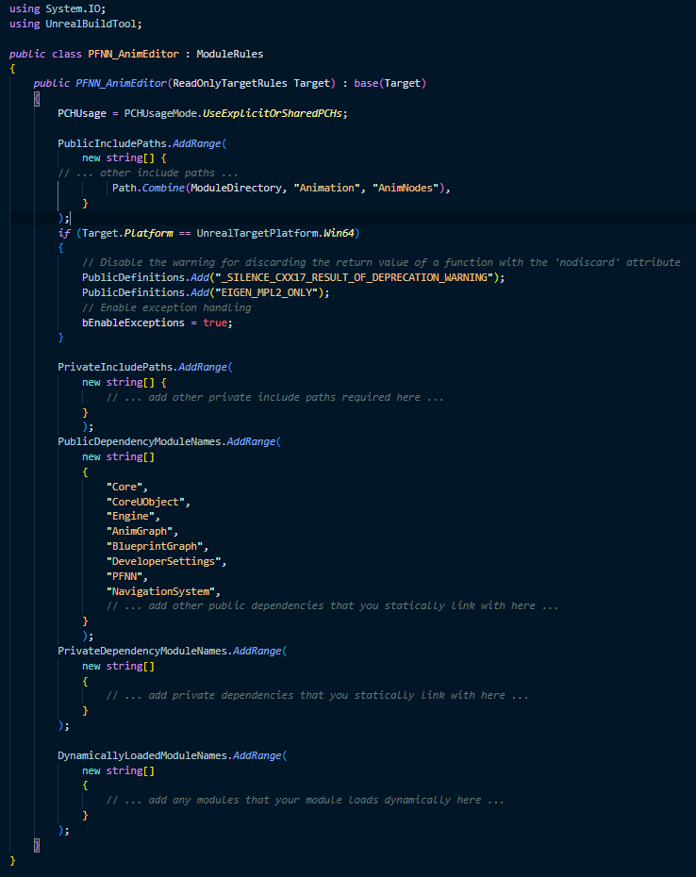

## Appendix 2

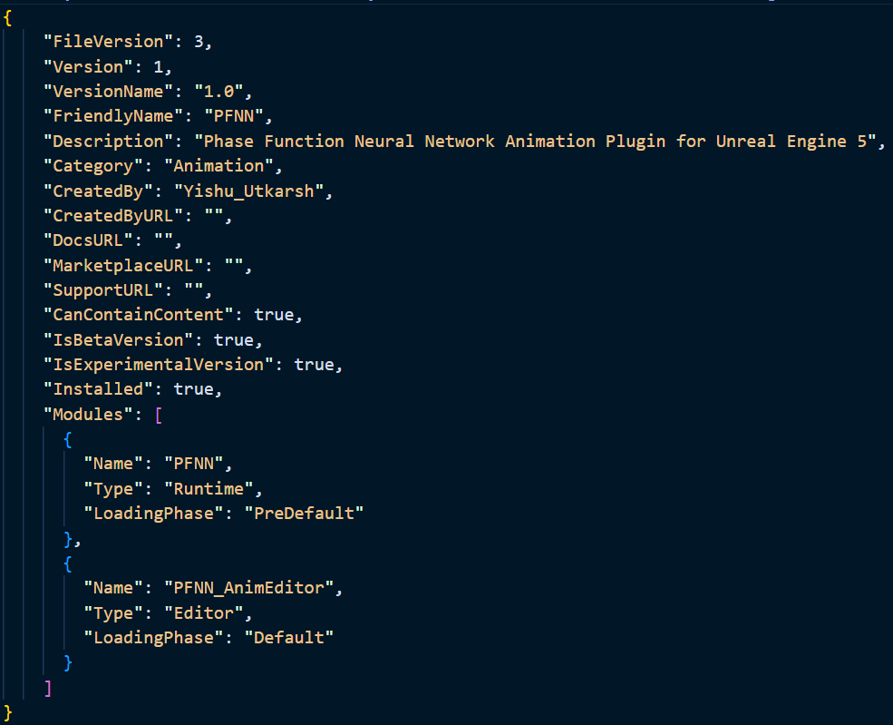

## Appendix 3



## Appendix 4



## Appendix 5

